SPE Annual Technical Conference and Exhibition (ATCE), 21–23 October 2026, Houston, Texas, USA
SPE-234136-MS

A Conversational User Interface For Autonomous Reservoir Simulation Deck Generation And Execution

I. Matejka¹, W. Laube¹, and D. Perschke²
¹ Blauweiss EDV
² Consultant
Abstract:
Objectives/Scope: This paper presents CLARISSA (Conversational Language Agent for Reservoir Integrated Simulation System Analysis), a conversational agent that autonomously generates, executes, and analyzes reservoir simulation models from natural language input. Engineers describe what they want; CLARISSA delivers working models. To enable standardized comparison of conversational deck-generation systems, we introduce RIGOR (Reservoir Input Generation Output Review), a benchmark for evaluating CLARISSA and future similar efforts.
Methods, Procedures, Process: CLARISSA employs large language models integrated with OPM Flow through a multi-stage translation pipeline that converts natural language problem descriptions into PetroScript, a typed, simulator-independent authoring language whose compiler currently emits Eclipse-format deck syntax. The system supports multiple input modalities: voice, text chat, web interfaces, and REST APIs. Physics-aware validation flags inconsistencies during conversational elicitation, while analog databases suggest reasonable defaults for incomplete specifications—all assumptions are explicitly documented. Generated decks execute autonomously on OPM Flow; outputs can be exported for commercial platforms when third-party validation is required. RIGOR employs execution-based evaluation using simulator diagnostics including convergence behavior and material balance closure.
Results, Observations, Conclusions: CLARISSA successfully generated decks for SPE comparative solution projects including SPE1 (Odeh, 1981), SPE5 (Killough and Kossack, 1987), and SPE9 (Killough, 1995) from text and tabular input specifications. Generated decks executed without error and matched published benchmark results. Beyond validation cases, CLARISSA demonstrated autonomous model reformulation: given only a compositional table, the system converted a black-oil model to a fully compositional equation-of-state formulation without additional user intervention. This capability enables rapid evaluation of tertiary recovery options from existing assets. RIGOR defines complexity tiers from foundational (linear displacement corefloods) through intermediate (multi-well pattern floods) to advanced scenarios requiring mid-conversation compositional pivots. Execution-based scoring derives from simulator diagnostics: convergence behavior, material balance closure, and physical constraint satisfaction. The binding constraint on simulation adoption has never been solver performance—it is human cognitive load and workflow friction. CLARISSA eliminates both commercial licensing barriers and the specialist training traditionally required, enabling practicing reservoir engineers to directly leverage simulation capabilities previously accessible only to dedicated specialists.
Novel/Additive Information: Unlike prior work focused on querying existing models (SPE-221987) or retrieving reservoir data through pre-built tool functions (SPE-229646), CLARISSA is the first system capable of generating—not merely querying or modifying—complete simulation decks from natural language. RIGOR provides the first standardized benchmark for evaluating conversational deck-generation systems, enabling reproducible comparison of future approaches analogous to established benchmarks in software engineering code generation. PetroScript, to be released alongside RIGOR, is to our knowledge the first typed authoring language for reservoir simulation decks designed to be simulator-independent, replacing positional keyword syntax with named, validated parameters.
1. Introduction
Reservoir simulation was conceived to inform reservoir management decisions at every scale, from development planning to routine surveillance. On every technical axis, the prerequisites have been met. The governing physics were settled by mid-century; the numerical machinery was mature by the 1980s (Peaceman 1977; Aziz and Settari 1979; Coats 1980); solver performance has improved by orders of magnitude; and industrially validated open-source simulators are now freely available (Rasmussen et al. 2021).
Deployment has not followed. Simulation today is used much as it was in 1990: a major-project tool, executed by a small specialist community, largely absent from routine surveillance, and accepted but rarely used in reserves determination. The day-to-day decisions that, in aggregate, govern ultimate recovery are typically made without consulting a physics-complete model, even in assets where one exists. Reserves determination continues to rest principally on empirical rate-time relations (Arps 1945), selected not for their physics but for their cost-to-answer.
This paper argues that the gap between capability and deployment has a single dominant cause — the manual translation of engineering intent and field data into simulator input structures — and that this cause, previously unaddressable, can now be addressed directly. We present CLARISSA, a conversational agent system that performs the translation, and RIGOR, an open benchmark under which its claims can be tested rather than accepted on demonstration.
2. The Missing Component
The pattern of prior remediation attempts identifies the constraint by elimination. Efficiency gains in a resource normally expand its consumption (Jevons 1865). In simulation this held only on the intensive margin: as computation cheapened, the existing user community built larger models and ran ensembles, while the extensive margin — users, occasions, questions asked — moved little. Streamline and GPU acceleration (Thiele 2001; Datta-Gupta and King 2007), digital-oilfield data logistics, closed-loop reservoir management (Jansen et al. 2009), the shared earth model (Mallet 2002; Perrin and Rainaud 2013), and free validated solvers each relieved one constraint without expanding the user base.
Five candidate constraints — speed, data logistics, automation, integration, and price — have thus been relieved at industrial scale, each without a measurable adoption response; we refer to this pattern throughout as a null adoption result, meaning that the population of users, occasions, and questions did not expand after the constraint was relieved. These efforts share a structure: each assumed the human-to-deck translation step as given and built above or below it. The translation step itself was never addressed, because doing so was not technologically possible.
The argument is an elimination test with a stated counterfactual. If translation were the binding constraint, then relieving any other constraint would leave the extensive margin unchanged, because the population able to author or modify a deck would be the same before and after. If instead the relieved constraint were binding, the population of users, occasions, or questions would expand measurably after its removal. Table 1 states, for each wave, the observation the second hypothesis predicts and the observation recorded. In every case the record matches the first hypothesis. The test is correlational but directional: a single wave producing extensive-margin expansion without addressing translation would have falsified the thesis, and none did.
Table 1—Elimination test across prior remediation waves. For each constraint relieved, the observation predicted if that constraint had been binding, and the observation recorded. The GUI era is the one wave that addressed translation directly, and it produced the partial expansion the thesis predicts for a partial solution.
Wave | Constraint relieved | Predicted if this constraint were binding | Observed
Streamline / GPU acceleration | Speed | New users and occasions as run cost falls; routine questions become economic | Existing users built larger models and ran ensembles; user base unchanged
Digital oilfield | Data logistics | Simulation model becomes the operational hub once data reaches it | Data reached the model; the model did not become the hub
Closed-loop reservoir management | Automation | Sustained field deployments once matching and optimization are automated | Pilots demonstrated; sustained deployments scarce
Shared earth model | Integration | Deck construction accelerates once upstream disciplines are integrated | Integration achieved upstream; deck-side constraint unchanged
Open-source solvers | Price | Adoption response outside the sponsoring community once license cost is zero | Little response outside the sponsoring community
GUI era | Translation (attempted) | Extensive margin opens if the interface reaches the full specification space | Engineers could execute existing models but not audit, defend, or restructure them; off-menu cases routed back to specialists

The mechanism by which translation gates adoption is organizational. Practicing simulation requires two orthogonal competencies: reservoir engineering judgment, and fluency in a formal input language of some fifteen hundred constructs — a skill that decays between uses faster than intermittent exposure replenishes it. Because individuals holding both are rare, the industry concentrated them in centers of excellence and rationed their time, producing a three-tier structure — specialist, asset engineer, surveillance engineer — in which each tier holds judgment the others lack. Division of labor functions, however, only when the artifacts crossing organizational seams are legible to both sides, as depletion plans and forecasts are. The simulation deck is not: when a model is handed off, the artifact transfers but the understanding does not. A simulation question must therefore travel from the engineer holding its context to the specialist holding the tool — scoped, queued, and budgeted — to be answered in a model containing few of the operative constraints. Many questions are simplified, deferred, or never posed; this unmeasured non-use is the larger loss, of which the visible substitution of empirical methods is an indicator.
The constraint binds hardest over a model's life. Routine events — a revised fluid study, a new well contradicting the property model, a stimulation to be represented — cost the model's author hours and any inheritor far more, because the effort is dominated by recovering unrecorded intent: the deck records what was done, not why. An inheritor consequently faces two prices for any update — a budgeted specialist engagement, or none — and the recurring rational choice is to run the model unchanged and qualify the results. Models are rarely retired because they fail; far more often they become uneconomic to modify.
The graphical-interface era warrants separate treatment, because it was the industry's direct attempt at the translation problem and its failure was misread. The investment produced engineers able to execute existing models but not, in most cases, to audit, defend, or restructure them. The cause is structural: a forms-based interface anticipates a finite set of cases and fails on those outside it — the off-menu question, the irregular input, the unanticipated edit — and each failure routes back to the specialist. The residual complexity of simulation is not algorithmic, which interfaces can encapsulate, but specificational: judgment expressed in a formal language, which menus cannot hold. The GUI era's conclusion that accessibility had been tried and found infeasible was therefore premature: the threshold had been reorganized, not removed.
The requirements for the missing component follow. It must operate across a semantic boundary — professional intent on one side, formal structure on the other — and it must act: read an artifact, form hypotheses, search, adjudicate alternatives, execute, and verify. No technology satisfying both requirements existed before large language models and the agentic systems built on them.
3. CLARISSA
CLARISSA (Conversational Language Agent for Reservoir Integrated Simulation System Analysis) supplies this component. Engineers state intent in their professional language; the system converts it into executable models, requests clarification when a specification is incomplete rather than resolving ambiguity silently, and supports every answer with an executed simulation that has passed the validation cascade of Section 5. The interface is conversational; the verification is not.
The design inverts what is preserved. Historically the durable artifact has been the deck, with the intent that produced it discarded at translation. CLARISSA preserves intent as the durable, legible artifact and treats the deck as a compilation product, regenerated on demand; rationale is recorded at generation and re-derived with each regeneration, so documentation cannot diverge from content. The same agentic capability operates on the legacy corpus: an inherited model is parsed, its dependencies located and adjudicated, a closed file set assembled, and custody verified by reproducing the predecessor's results before edits are accepted. Because intent is the preserved artifact, the input dialect is an implementation detail and the solver a replaceable backend. The architecture is presented in Section 5.
4. Scope of the Objective
Removing the translation constraint changes the economics of simulation use in specific ways. Intervention cost scales with intervention size, where previously any update carried either specialist-engagement cost or none. A model can incorporate new field information as it arrives rather than drifting from the asset. Questions can be posed by the engineer holding the operative constraints at the time they arise. The legacy inventory becomes serviceable through verified custody transfer; prior infrastructure investments gain their intended counterpart; and with license cost removed and the fluency requirement absorbed, simulation becomes available to operators previously excluded by its fixed costs.
The claim should be read precisely: what is removed is the fluency requirement — one half of the dual skill stack — not the engineering half. Physics assessment, feasibility screening, and operational vetting remain with the engineers who hold them.
The obvious objection: each prior wave carried comparable expectations. The response is structural and empirical: the prior waves share an identifiable common gap; the present approach is defined by filling that gap with a technology category that did not previously exist; and its claims are submitted to an open benchmark under which they can fail. Section 6 demonstrates the objective on worked cases spanning the three organizational tiers; Section 5.4 presents the benchmark.
5. Methodology
This section presents the system architecture (5.1), the PetroScript semantic authoring library (5.2), the decision to rely on in-context learning rather than fine-tuning (5.3), and the RIGOR benchmark and its scoring (5.4).
5.1 System Architecture
The CLARISSA agent is proprietary. Its internal engineering — state schemas, dispatch and routing criteria, comparator mechanics, sampling policy, prompts, and harness design — is deliberately withheld, and this section describes the system only at the level of organization and contract: which agents exist, what each may and may not do, and what every released model must survive (Fig. 1). What is disclosed in full is the RIGOR benchmark of Section 5.4: its task construction, grader calibration, scoring algorithm, tolerance criteria, and results are described completely and released as open source, so that the claims made for CLARISSA can be scored, and failed, by anyone, independent of the agent's implementation.
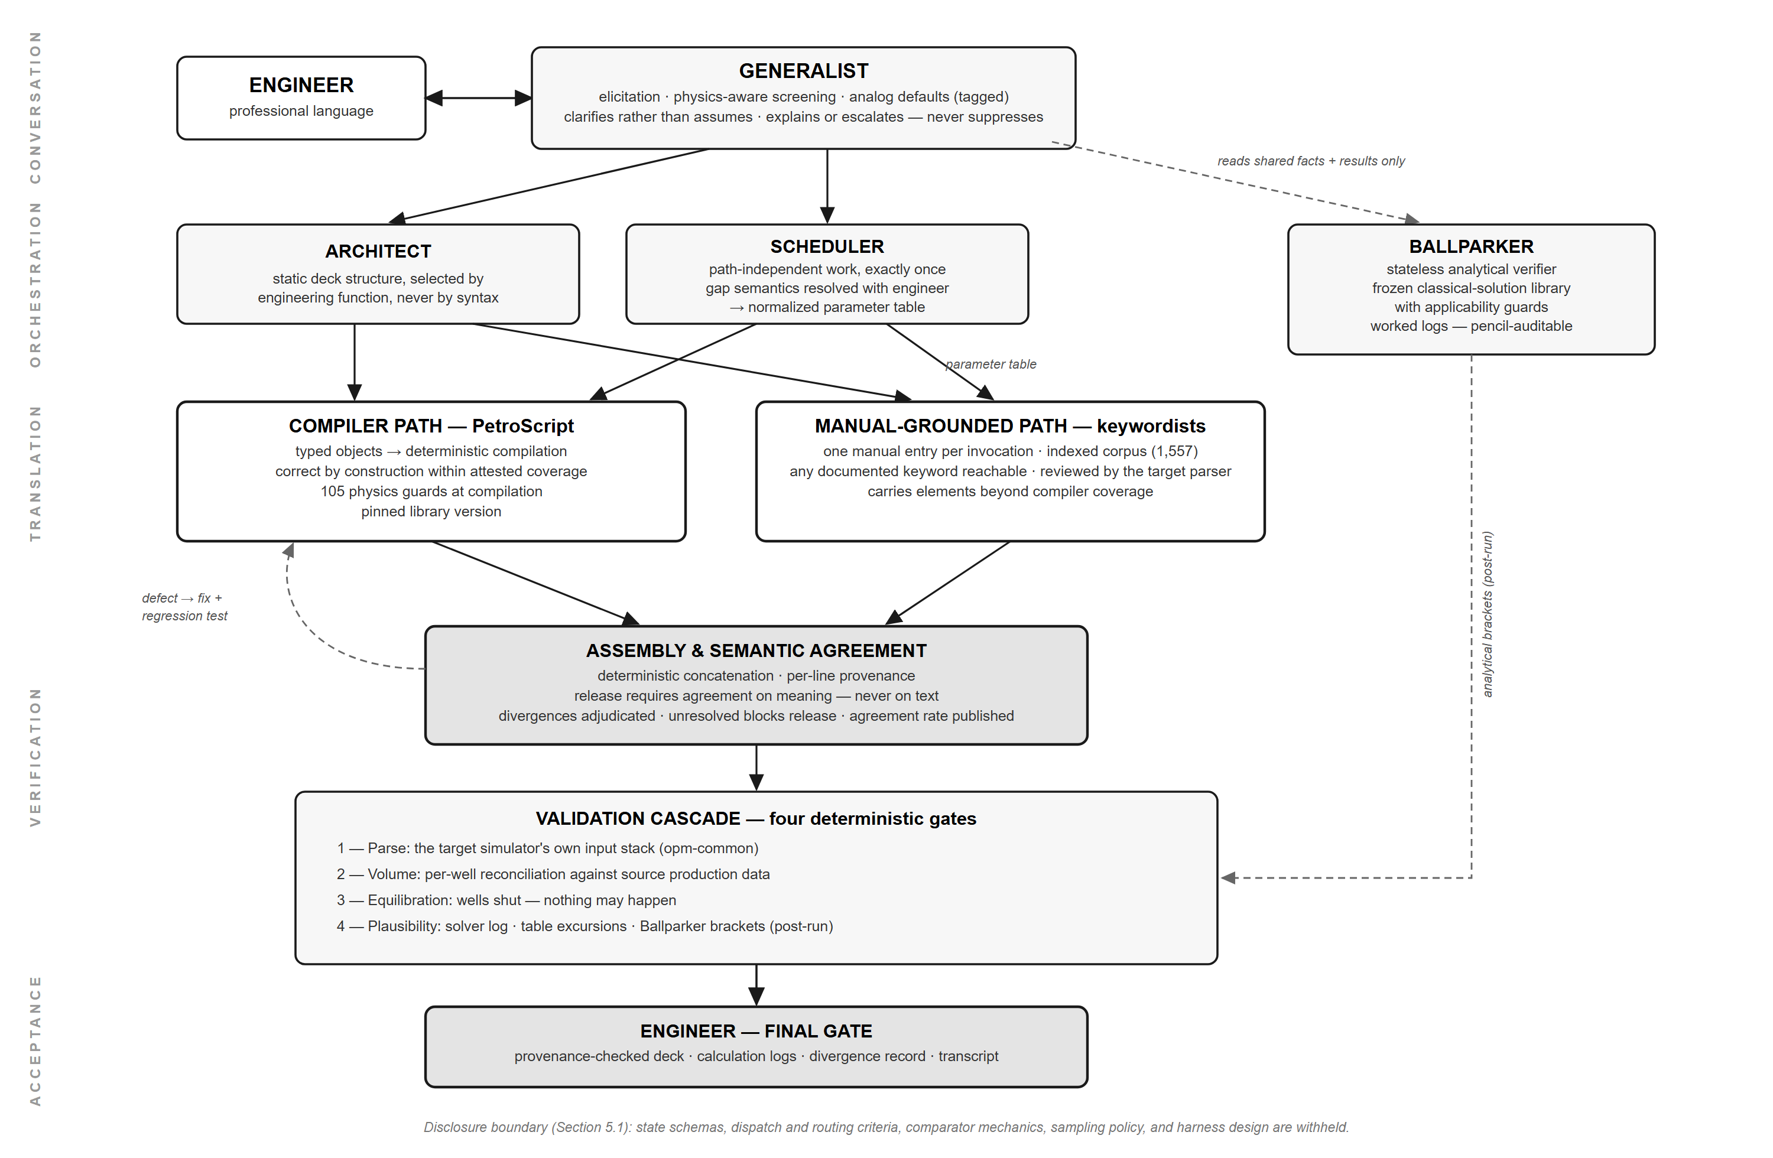
Fig. 1—CLARISSA architecture and gated workflow. The generalist orchestrates the architect, scheduler, and Ballparker; compiler and manual-grounded translation paths converge at semantic agreement, pass four deterministic validation gates, and return to the engineer for final acceptance.
Design principles. Five principles govern the architecture, each answering a characteristic failure mode of language models applied to formal-language generation. First, language models operate only at semantic boundaries: they are engaged where meaning must change form — engineering intent into deck structure, an irregular production spreadsheet into a clean schema — while every mechanical transformation between those boundaries is performed by deterministic code, which does not hallucinate and executes at negligible marginal cost. Second, verbatim transfer is guaranteed by construction, not by instruction: no agent is asked to reproduce text token-by-token; content that must move unaltered moves as a file reference and is concatenated by code, so every line of a released deck traces to exactly one producing step. Third, the consuming machine is the sole syntax reviewer: the target simulator's own input stack — opm-common for the OPM Flow target (Rasmussen et al. 2021) — is the syntactic authority, applied as a gate after assembly. Fourth, knowledge-rich components are kept procedurally lean: broad-reasoning components remain specification-free, while rigorous, interpretation-free procedure is confined to narrow components that each hold one reference document for one task. Fifth, where guarantees differ, run both and compare: for its default target, the system translates intent through two independent paths and releases a deck only on their semantic agreement. Together these principles yield a neurosymbolic system: neural components propose, symbolic components dispose; neural components are never load-bearing for correctness, and symbolic components are never asked to interpret intent.
Agent organization. The system is organized as a small hierarchy of agents with deliberately asymmetric contracts.
The generalist is the conversational tier and the only agent the engineer addresses. It is knowledge-rich and procedurally lean by design — the fourth principle applied at the top: its work is elicitation in professional language, physics-aware screening of the emerging specification, analog-based defaulting where the specification is incomplete (with incompleteness otherwise resolved by a request for clarification rather than a silent assumption), and adjudication of verification findings. Its adjudications are bounded by a transparency contract: every verification component reports raw results upward, and the generalist may explain a finding from documented facts or escalate it to the engineer — it cannot suppress one, and its explanations are logged.
The architect owns static deck structure, selecting and sequencing content by engineering function, never by syntax. The scheduler performs the path-independent schedule work exactly once — gap semantics resolved with the engineer rather than assumed, unit normalization with conversion lineage, and the regime-transition list — producing a normalized parameter table from which schedule content is replicated by deterministic code; between regime transitions, schedule generation involves no language model. The keywordists are the narrowest agents in the system and the fourth principle's purest expression: each receives one specification, reads one reference-manual entry served by a deterministic index over the corpus, populates one keyword, and returns its block; the elevation is transient, so repeated invocations are answered from the entry rather than from accumulated pattern.
The Ballparker is a stateless analytical verifier that produces no deck content: a frozen, tested library of classical solutions — volumetric fluids-in-place, material balance, displacement theory, decline consistency, fluid-property correlation bands — each carrying an explicit applicability guard. Its judgment is confined to tool selection against the guards, parameterization, and report assembly, and every result returns as a worked calculation log — inputs with provenance, conversions shown, named intermediates, residuals — auditable with a pencil. It computes and reports; it never adjudicates. It reads only the shared state and simulation output, never the authoring artifacts, so it cannot inherit the producers' assumptions.
Shared state is held in the ledger: a typed, schema-validated store that refuses invalid writes. Every recorded value carries a provenance tag — user-supplied, literature- or correlation-constrained, or analog-defaulted — and validation against physical invariants (closure, ordering, cross-consistency) is a precondition for commissioning any deck generation. There is no override path: a rejected value is reported conversationally with the violated invariant named, and no repaired value enters the record without the engineer's confirmation. Provenance tags propagate to the released deck, so the assumption audit trail exists by construction.
Two translation authorities. For the default target — the Eclipse dialect on OPM Flow — intent is translated into a deck through two independent authorities with complementary guarantees: a semantic compiler path built on PetroScript (Section 5.2), correct by construction within an attested, versioned coverage; and a manual-grounded path in which keywordists generate each block from its manual entry — any keyword documented in the reference corpus (1,557 indexed entries) reachable — with every result submitted to the target parser — deep-but-partial against shallow-but-total. Where both authorities apply, both author independently from the same recorded facts, and release requires semantic agreement: equivalence is evaluated on normalized meaning, never on text; every divergence is adjudicated to a recorded cause; an unresolved divergence blocks release; and the running agreement rate, reported per deck section, is a first-class reliability statistic of the system. Elements beyond compiler coverage are carried by the manual-grounded path alone, and field work steadily converts uncovered scope into covered scope under human review.
The validation cascade. Four deterministic gates stand between generation and acceptance. Gate 1 — parse: the released deck is parsed by the target simulator's input stack, and a failure routes the machine's message to the producing component. Gate 2 — volume reconciliation: cumulative volumes summed from the source production table are compared, per well, against the volumes implied by the emitted schedule — an identity that catches the column-mapping and unit-conversion errors a parser cannot see. Gate 3 — equilibration: before scheduled activity, the model runs a synthetic settling period with all wells shut, and the acceptance criterion is that nothing happens — pressures flat, phase volumes static, inter-region flows nil; a model that drifts has demonstrated, in the simulator's own arithmetic, that its initial state was not an equilibrium state. The same machinery confirms initialized in-place volumes against the initialization report. Gate 4 — analytical plausibility: after execution, a deterministic harvester collects solver warnings and convergence diagnostics; a table auditor compares state trajectories against the registered validity domain of every input table; and the Ballparker compares results against its analytical brackets, reporting each as a worked calculation log. Gate 4 flags departure from an envelope, not from an equality; residuals beyond a configured band surface to the engineer regardless of any explanation generated en route.
Dual-path agreement also hardens the system over time: a divergence adjudicated as a compiler defect is captured as a minimal reproduction, the repair ships with a regression test, and the agreement rate tracks the accumulation of these lessons in reviewable code.
The checks enforced across state validation, path agreement, and the four gates are cataloged in a versioned registry — 23 checks at v0.3, classified as static invariants, analytical envelopes, and dynamic self-consistency, including edit-mode checks inherited from six generations of predecessor systems. The registry operates at the model level and is distinct from the compile-time guards of Section 5.2, which operate at the language level. It is released as a community artifact under RIGOR (Section 5.4).
The engineer is the final gate. Acceptance rests on generated audit artifacts — the deck with per-line provenance, the calculation logs, the divergence and adjudication record, and the conversation transcript — and no claim in the acceptance chain requires trusting a model's assertion: every claim terminates in a parser, a conservation identity, a settled analytical solution, a published statistic, or a document the engineer can read.
Properties. Four properties follow from this construction. Reformulation is regeneration: a mid-conversation paradigm change, such as black-oil to compositional, invalidates a specific slice of the recorded problem and recommissions only the affected elements. The division of labor is explicit: the language-model agents (architect and keywordists) decide the reformulation and author the new content — in the compositional case of Section 6 the engineer supplied the component table and the agents translated it into the EOS and PVT sections — while the Ballparker brackets the resulting fluid properties against classical correlations without producing deck content, and the scheduler regenerates schedule content deterministically. “Autonomous” denotes no manual deck editing between instruction and executable result, not the absence of deterministic machinery. Simulator-specific knowledge is confined to a replaceable reference corpus and validating input stack, so retargeting preserves the structure above them. Cost scales with the number of semantic decisions rather than with deck volume, which is produced by code. And reliability is quantified in operation rather than asserted: the agreement rate, divergence record, and gate statistics are continuously produced operating data — the same quantities RIGOR scores — so internal quality control and external evaluation are one instrument.
5.2 The PetroScript Semantic Authoring Library
Section 5.1 introduced the compiler path by its guarantees; this section describes the library that provides them, to be released as open source alongside RIGOR.
Early experimentation established that language models could author basic simulation decks directly in Eclipse-dialect syntax, but reliability degraded sharply with problem complexity, and observed failures divided into syntactic errors and engineering-judgment errors, with syntactic errors dominating for smaller models. Syntactic correctness is a prerequisite for measuring judgment: a deck that fails to compile yields no signal about the model's engineering. An initial mitigation — a specialized subagent consulting the reference manual at generation time — reduced syntactic errors substantially but, in the model generation then current, demanded frontier-class capability at significant inference cost. These observations motivated PetroScript, but did not retire the manual-consultation approach: matured into the indexed manual-grounded path of Section 5.1, it was retained as the second translation authority, independent of the compiler in exactly the way dual-path agreement requires.
Both motivating observations date to that earlier model generation, and subsequent base-model progress has substantially dissolved the first: contemporary models author manual-grounded blocks with high syntactic reliability at costs no longer confined to frontier-class deployments (Section 6). The architecture anticipates this migration — the design position of Section 5.3 applied to the system's own components — and the compiler path's enduring contributions are those the capability curve does not erode: it is the deterministic authority against which the stochastic path's agreement is measured, a guarantee no language model can supply for its own output; it produces deck volume at negligible marginal cost, the natural carrier for ensemble and sweep workloads; and it establishes a typed, readable authoring surface for the Eclipse dialect.
PetroScript is a Python-embedded domain-specific language intended as a simulator-independent authoring language for reservoir models: a typed, semantic front end from which simulator input is generated by a deterministic compiler. The present compiler targets Eclipse-compatible syntax, which covers ECLIPSE, OPM Flow, JutulDarcy, and other simulators that accept that dialect; targets with distinct syntaxes are future work (Section 7). Fig. 2 shows a representative program and the SCHEDULE section it renders. The library substitutes semantic, typed authoring for positional keyword format: each argument is a named, described parameter, and the compiler performs ordering and formatting — abolishing the transposition errors that positional syntax invites. The language choice reflects the training-data distribution of contemporary code models: The Stack v2 contains 191.61 GB of Python, while a 10 August 2026 audit of the default-branch blobs in all 58 public OPM repositories totaled 3.86 GB across all file types—a conservative ratio of about 50:1 (Lozhkov et al. 2024; OPM 2026)—so authoring in Python places generation within a substantially higher-resource language distribution. This is a design motivation, not a measured effect; the ablation of Section 6 does not separate language familiarity from typed validation. The library ships 105 physics guards spanning hard errors to advisory warnings, surfacing unit errors, order-of-magnitude errors, and physical inconsistencies at compilation — before a simulator run — rather than through convergence failure after one; Fig. 3 shows one guard from each class. Any program passing its type and guard checks compiles to a syntactically valid deck, a property validated during development against the full corpus of approximately 700 open-source OPM decks. Roughly 60 of those decks do not run in OPM Flow because they use Eclipse keywords Flow has not implemented; PetroScript compiles them, and the limitation is the target simulator's, not the compiler's.
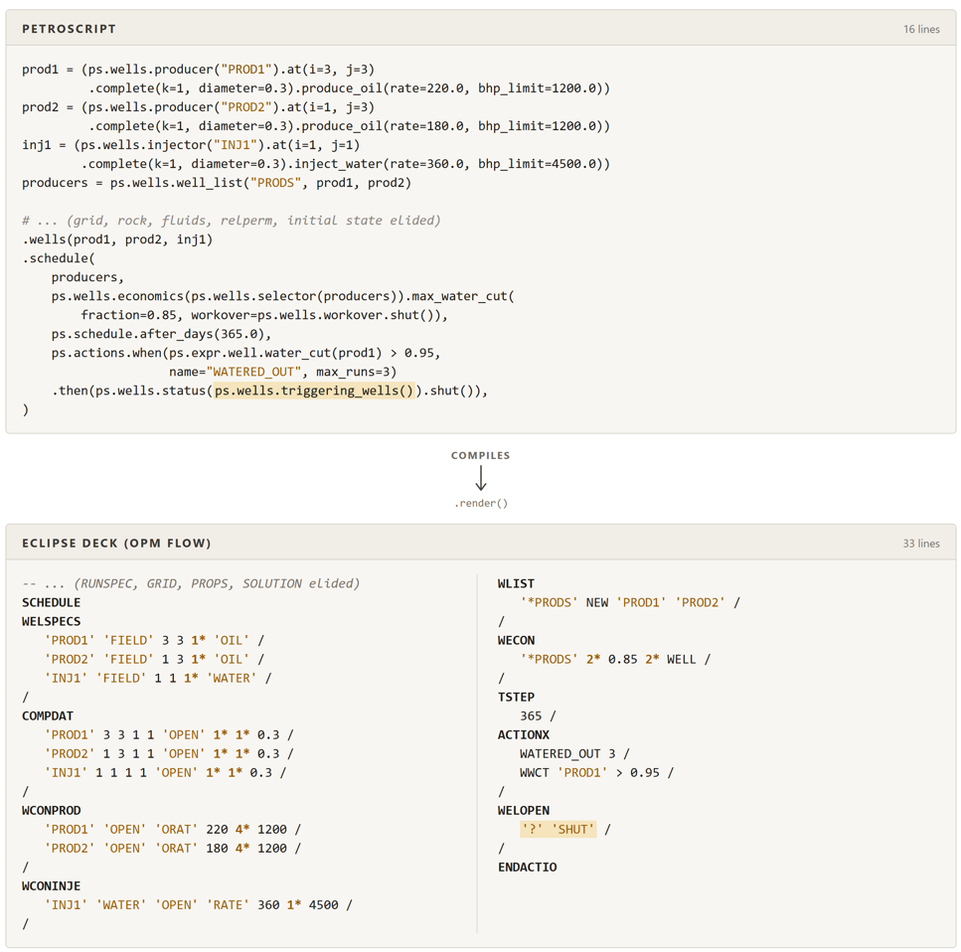
Fig. 2—PetroScript source and the Eclipse deck it compiles to. Top: a 16-line program declaring two producers, one injector, a well list, an economic limit, and a conditional action, each parameter named and typed. Bottom: the 33-line SCHEDULE section it renders as positional keyword blocks. Highlighted: triggering_wells() compiles to the '?' wildcard in WELOPEN. Other sections elided.
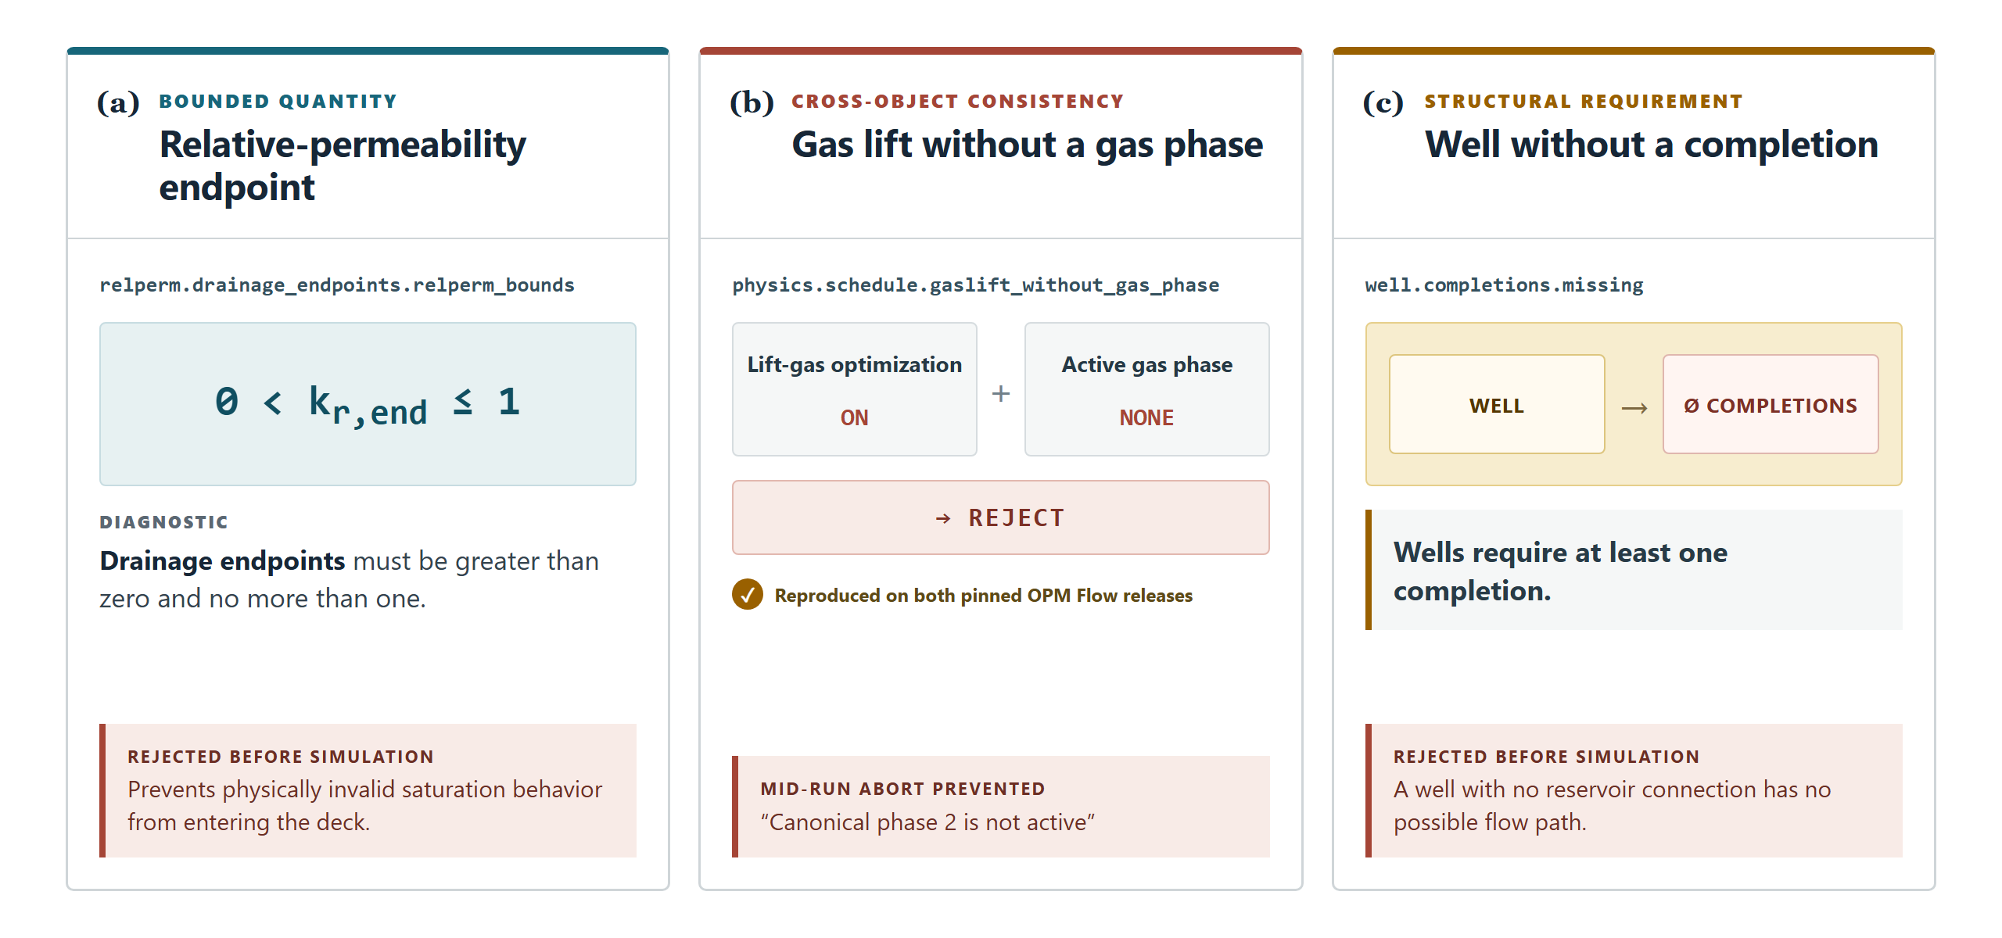
Fig. 3—Three of PetroScript's 105 physics guards, one from each class. (a) Bounded quantity: relative-permeability drainage endpoints must satisfy 0 < kr,end ≤ 1. (b) Cross-object consistency: lift-gas optimization is rejected when no gas phase is active, preventing a mid-run abort that both pinned OPM Flow releases otherwise produce. (c) Structural requirement: a well declared without a completion has no flow path and is rejected. All three fire at compilation, before any simulator run.
Cross-target portability is carried by the manual-grounded path, which is operational on a new simulator as soon as its reference corpus is indexed and its input stack installed as the parse gate; the compiler path follows per target, its extensions drafted from the same manual entries under human review and commissioned under dual-path agreement against the manual-grounded path. The pinned library version advances only through the repair loop of Section 5.1, so successive versions are monotonically hardened against accumulated field counterexamples.
5.3 Design Decision: In-Context Learning versus Fine-Tuning
With syntactic errors largely addressed by the architecture and the library, the remaining gap is engineering judgment, and two considerations led us to rely on in-context learning and harness design rather than fine-tuning. The first is the data wall: a survey of the open internet located approximately 700 OPM-compatible decks, which with all open documentation amounts to tens of millions of tokens — well short of what effective domain adaptation requires. The second is depreciation and generality: base models improve on a cadence of months, so a fine-tuned checkpoint depreciates against successive bases; driving an agentic harness is itself a demanding capability that smaller specialized models would need to be retaught; and in our testing, smaller models exhibited weaker engineering judgment irrespective of domain exposure (Section 6). In-context learning and harness design are model-agnostic, scale with each improvement in base-model capability, and are cheaper to iterate. The system nonetheless accumulates its lessons continuously in a different hypothesis class — the repair loop of Section 5.1 stores them in reviewable, versioned code and tests. Fine-tuning remains future work with a specific enabler: the system, in operation, can serve as a teacher, generating the verified traces that would close the data gap for a subsequent effort on a stronger open base.
5.4 The RIGOR Benchmark
Evaluating an agentic deck-generation system presents its own challenge. Wiegand et al. (2024) described a retrieval-augmented reservoir-simulation assistant combining simulator-, model-, and execution-specific knowledge bases with static analyzing agents and dynamic callback agents. Although its abstract identifies deck creation, modification, and translation as target uses, the paper's reported prototype scope demonstrates simulator-knowledge and model-property queries and explicitly leaves model manipulation and rapid results analysis outside the work covered. Zhao et al. (2025) described a tool-using reservoir-management agent. CLARISSA instead targets end-to-end generation and modification of executable decks, and RIGOR (Reservoir Input Generation Output Review) is designed to evaluate that behavior under executable checks. Construction began from a survey locating approximately 700 open OPM decks, a minority accompanied by published papers (SPE1, SPE5, SPE9) or field documentation (Volve, Norne). From this corpus, 135 decks were selected and synthetically mutated by the procedure described below to form the RIGOR task set; the remainder serve as the mutation pool for subsequent versions.
Contamination control. Well-studied reference decks and their derivatives appear widely in open literature, so a model may reproduce memorized content rather than reason to a solution. RIGOR applies two mutation classes. Semantic mutations alter coupled numerical inputs—including geometry and properties, pressure and rate targets, well locations, controls, and schedule values—while preserving the intended engineering regime. Lexical mutations remove source fingerprints by aliasing cases, wells, groups, and include files; substituting accepted keyword dialects or synonym classes; deleting identifying comments; and changing whitespace and formatting. Lexical changes do not count as numerical displacement. Each mutated oracle is re-run in the pinned OPM Flow environment and rejected if it fails to complete, produces non-finite or physically invalid results, misses the requested end date, or exhibits pathological behavior. A 5% band on conservation anchors — pore volume, initial hydrocarbons in place, and recovery where applicable — bounds how far a mutated deck may depart from its parent. The value is a design hyperparameter, not a derived quantity: it was chosen to make mutated decks numerically distinct from their sources while keeping them within the parent's engineering regime, and it is unrelated to the grader tolerances described below. Mutation review also compares the final field responses FOPT, FPR, FGPT, FWPT, FWIT, FGIT, FWCT, and FGOR, together with task-specific rates, breakthrough, storage, and control behavior, under family-specific criteria. The current implementation therefore does not claim one universal executable 5% parent-displacement test.
Task construction. Tasks reflect a practicing engineer's workflow across three classes in approximately even proportion: authoring (query and sidecar files to output deck), editing (a specified modification to an existing deck), and repair (a defective deck with its error log, to be diagnosed and fixed). Because early problem generation tended toward cookbook phrasing — every required datum stated in prose, reducing the task to transcription — all problems received a second pass: values derivable from stated conditions and constants a practicing engineer knows were omitted, methodological instructions were removed, and explicit values were replaced with regional context from which an engineer infers plausible compositions and constants. The result is task phrasing resembling a real engineering request, with judgment deliberately left as the tested quantity.
Scoring. Scoring approaches for agentic benchmarks fall into two families — LLM-as-judge, which accommodates subjective criteria but is bounded by the judge's competence (Zheng et al. 2023), and verified rewards, which are objective but demand careful environment design. Because contemporary models exhibit intermediate practitioner-level reservoir-engineering fluency, a fully judge-based scheme proved unreliable in our testing: judges tended to assign high scores to well-formed decks that were not physically correct (Section 6). RIGOR belongs to the lineage of execution-graded benchmarks: HumanEval (Chen et al. 2021) graded function-level code by running unit tests; SWE-bench (Jimenez et al. 2024) extended execution grading to repository-level repair and exposed the approach’s fragilities — score sensitivity to the agent harness, and documented memorization of the public task set; Terminal-Bench (Merrill et al. 2026) generalized the pattern to end-to-end agentic workflows in isolated environments with executable verification. RIGOR adopts Terminal-Bench's dedicated task environments and executable test suites (https://www.tbench.ai/), with one substitution that defines the domain: the ground truth is a numerical reservoir simulator rather than a unit test, so pass/fail becomes agreement within physically justified tolerance bands on a panel of production KPIs. The design was hardened through iteration: early rubrics rewarding surface form were promptly exploited, by keyword padding and by a sandbox escape, and each exploit produced a countermeasure: exact-set scoring with penalties for extraneous keywords, sandbox isolation, and inert integrity markers that convict byte-identical submissions. A subtler finding — that surface-form rubrics favor imitation over physical equivalence — is reported with the results (Section 6) and motivated the final weighting. The final rubric scores three categories: behavioral/structural (25%) — compilation, convergence, exact-set keyword and argument scoring, and integrity penalties; numerical (50%) — agreement of purpose-selected key performance indicators and production profiles with ground truth within tolerance bands. The numerical category compares the independently re-run submission with the mutated oracle. Its standard set comprises the OPM field summary vectors FOPT, FPR, FGPT, FWPT, FWIT, FGIT, FWCT, and FGOR when requested by the reference deck (OPM 2025a). Each final value receives credit when its relative error falls within a KPI-specific tolerance band; a missing vector fails, while two numerically negligible values are treated as equal. The bands are not uniform: they were set per KPI by a practicing reservoir engineer from experience of the expected behavior of each quantity, so that a deck reproducing the oracle physics passes and one that differs in regime does not. The complete tolerance table is released with the grader. The task author additionally selects three to six critical KPIs from the quantities that directly measure the task objective and declares their tolerances and weights in the task rubric. For time-resolved rate or pressure profiles, the submitted series is linearly interpolated to the reference report times and scored by the fraction of reference samples within the declared per-vector band. Standard vectors contribute 40% of the numerical category, with critical KPIs and profiles contributing the remaining 60% (Fig. 4); and process (25%) — a bounded language-model judge verifies the agent's rollout against a per-task reference of expected formulas, with assumed constants checked deterministically against reference bounds, capped and weighted so that judge error cannot dominate the verified signals. Numerical agreement carries the greatest weight on the principle that correct physics generally implies acceptable structure, while the converse does not hold; tolerance bands accommodate the run-to-run variation inherent in numerical simulation as well as the differing sensitivity of each KPI to timestep and solver settings. RIGOR is partitioned into three slices to control contamination: the public, training, and private slices contain 80, 20, and 35 tasks, respectively; within the public slice the task classes are held at 40% authoring, 30% editing, and 30% repair. A hard subset of 18 public tasks is designated for separate reporting. Membership was set by a stronger probe model, DeepSeek Pro, run under the control harness: tasks on which the probe scored below 0.6 pooled composite were classed as hard. The banding rests on one test — whether the solver can run both readings of the task and compare the result against anything in the task pack. Where it can, the task is climbable and frontier models climb it; every hard task is hard because it cannot, and correctness lives outside the workspace, in the physics. The public set is released with this paper, and every score reported here derives from it, so all results are reproducible from the repository alone. A separate internal training set was used to develop the DSL and prompts; it is disjoint from the public set, is never scored, and contributes no reported result. A third, randomly selected private set is withheld from publication and available to third parties through a hosted API for contamination-resistant comparison; it is not used for any result in this paper. No component of CLARISSA — prompts, check registry, or mutation thresholds — was iterated against the public set or the released rubric, including after the process-scoring recalibration described in Section 6; that recalibration adjusted the grader, not the system under test. Integrity countermeasures are described here by class, with specifics retained with the private slices (Fig. 5).
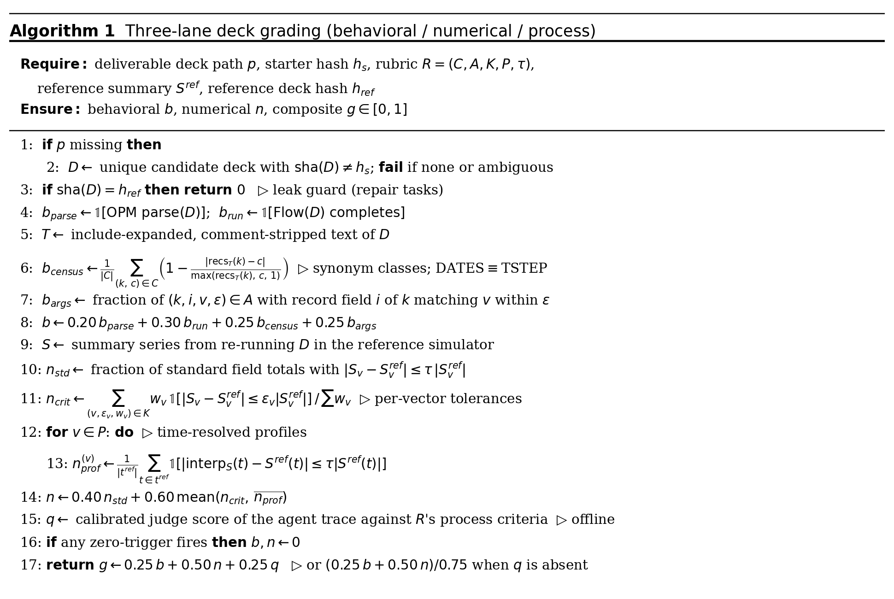
Fig. 4—RIGOR three-lane deck-grading algorithm. Deterministic behavioral and numerical lanes contribute 25% and 50%, respectively, and a bounded process lane contributes 25%; zero-trigger failures set behavioral and numerical credit to zero, and verified components are renormalized when process scoring is unavailable.
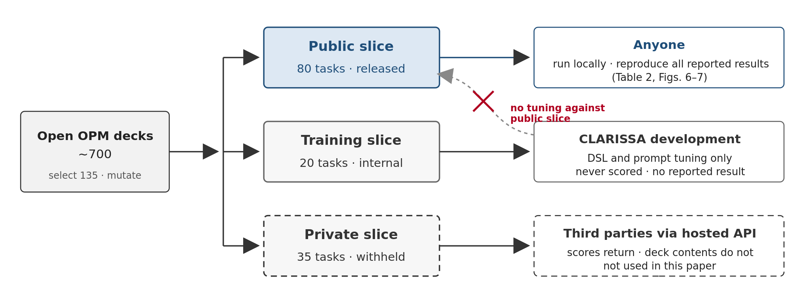
Fig. 5—RIGOR slice structure and access. Of roughly 700 open OPM decks, 135 were mutated into three disjoint slices: public (all reported results), training (development only, never scored), and private (scored for third parties via API without release). Development never tuned against the public slice.
6. Results
Results are reported in two parts: worked demonstrations of the system's objective (the capstone cases), and a controlled ablation study on RIGOR isolating the contribution of each architectural component.
Worked cases. In the preserved SPE1 Case 1 reproduction, the CLARISSA-generated deck and spe1/SPE1CASE1.DATA from OPM opm-tests commit 795d6fa462ee8d75f25539127358aa4a779c55fc were independently run with OPM Flow 2025.10 (OPM 2025b). The equivalence report compared all 42 summary vectors requested by that fixture across their recorded report steps and found zero mismatches at relative and absolute tolerances of 1 × 10−8 and 1 × 10−10, respectively. For each worked case, RIGOR's standard KPI panel comprises FOPT, FPR, FGPT, FWPT, FWIT, FGIT, FWCT, and FGOR; available vectors are compared at the final common report step under the per-KPI tolerance bands of Section 5.4, and missing vectors fail the comparison.
In the compositional reformulation case, the system received a black-oil model and a component table with an instruction to evaluate CO2 injection. It converted the model to a compositional equation-of-state formulation without further user intervention: the architect and keywordists authored the EOS and PVT sections from the table, the Ballparker bracketed the resulting fluid properties against its correlation bands, and the scheduler regenerated schedule content from the updated parameter table. The converted deck passed all four gates and ran to completion in OPM Flow.
In the custody-transfer case, the system received an inherited deck with dependencies spread across multiple include files. It parsed the deck, located and adjudicated the dependencies, assembled a closed file set, and verified custody by reproducing the predecessor's summary vectors within tolerance before accepting any edit. Only after reproduction did the system accept the requested modification, which passed the gates and ran to completion.
Ablation design. Four configurations were evaluated, each driven by the same base model — DeepSeek V4 Flash 0731 — so that every observed difference is attributable to the harness rather than the model. The control was a complete coding agent, not a bare language-model call: a Pi agent with its standard tool set (shell, file read, write, and edit), a generic prompt, the full OPM Flow reference manual on disk, and the same containerized OPM Flow and resdata environment used by every other configuration. It could look up any keyword, run any deck, and inspect any result; what it lacked was the subagent organization, the PetroScript path, and the CLARISSA protocol. The keyword-only and DSL-only lifts reported below are therefore measured against a capable baseline, and attribute to the subagent system plus protocol and to the DSL plus protocol, respectively. The second configuration retained the subagent organization of Section 5.1 but omitted the PetroScript authoring path; the third retained PetroScript but omitted the subagent organization; the fourth was the full system, with both. The two intermediate configurations are referred to below as the keyword-only and DSL-only agents. Results are reported from two evaluation series: an earlier k=4 series over all four configurations, and a closed-book series over the control and both single-path variants, run after network egress from the agent sandbox was blocked, on the full public slice at two trials per task (160 trials) with the 18-task hard subset run as an additional pass and reported separately. The closed-book series is used for the cross-model comparison below. Throughout, reasoning tier denotes the provider-exposed reasoning-effort setting of the base model. Because the two providers expose different ladders — DeepSeek V4 Flash offers none, low, high, and max; GPT-5.6 Luna offers none, low, medium, high, xhigh, and max — results are reported at three tiers common to both, labeled low, high, and max, using each provider's setting of that name. The ablation and Table 2 were run at the high setting on both models; that tier is referred to as the medium tier, since it is the midpoint of the ladders each model exposes.
Hard subset. Three examples fix what the banding selects for. A hard authoring task (an oil-rim field between a gas cap and an aquifer, probe score 0.20) has error-amplifying physics, each derived quantity feeding the next, and no workspace target to run and compare against; an easy one states its targets in the brief, so the agent iterates until its deck matches. A hard edit (a group-cap-to-UDQ migration with a new manifold, 0.45) expands the system, so the graded behavior belongs to a configuration that never existed and the starter deck stops being an answer key. A hard repair (0.18 to 0.35) plants faults that interact or mask one another and describes only how the system is wrong, never which record; the nastiest variant offers a computable self-check that is itself wrong.
Aggregate results. In the k=4 series the full system scored highest overall (0.82, against 0.80 DSL-only, 0.75 control, 0.70 keyword-only). Its margins were concentrated in the editing and repair classes (+0.05 and +0.04 over the best single-path variant); on scratch authoring it tied the DSL-only agent (0.715 vs. 0.717), with both well clear of the control. Between the single-path variants, the DSL-only agent scored higher on every task class — authoring 0.72 vs. 0.60, editing 0.87 vs. 0.81, repair 0.88 vs. 0.77 — though on repair the three configurations fall within confidence interval of one another in the closed-book series (Fig. 6, Table 2), consistent with the serial-verification effect described under Process below.
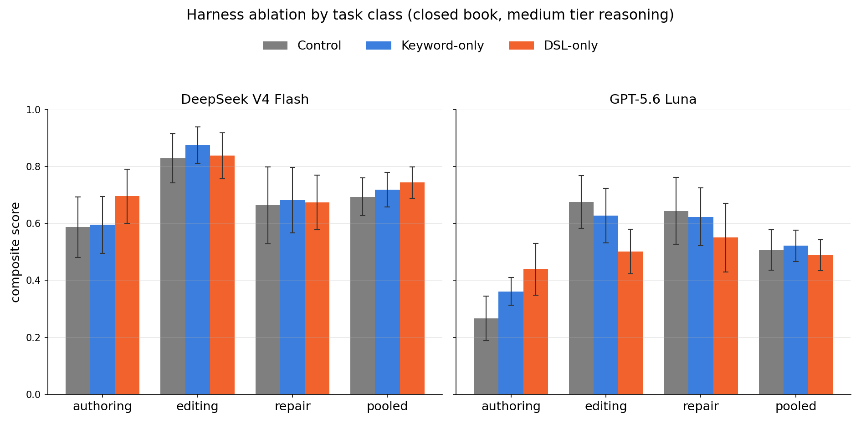
Fig. 6—Closed-book harness ablation by task class on the full public slice (80 tasks, two trials each, 160 trials; 64 authoring, 48 editing, 48 repair) at the medium tier (provider setting high on both models). Bars are composite score; whiskers are bootstrap 95% confidence intervals.
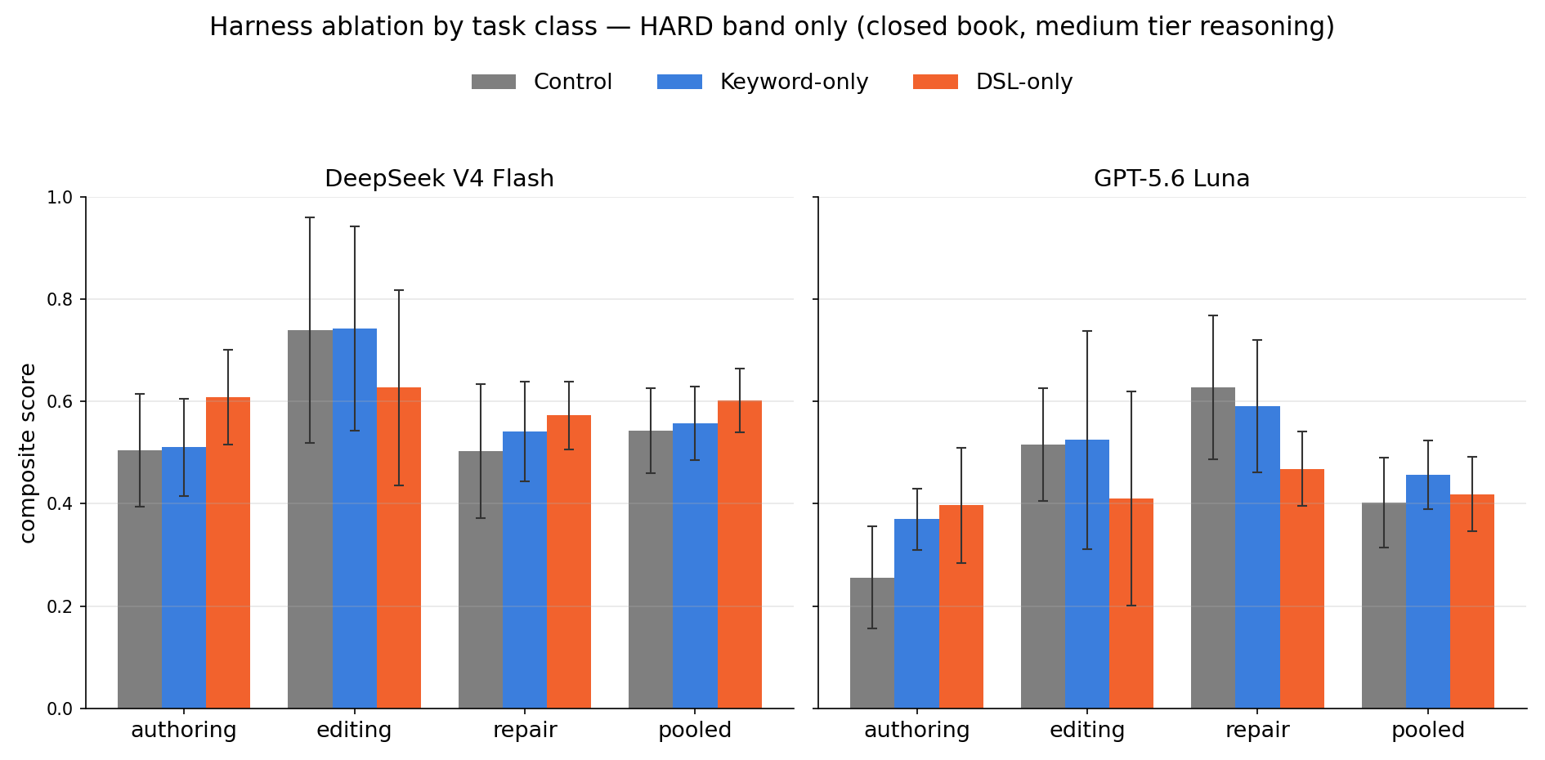
Fig. 7—Closed-book harness ablation restricted to the hard subset (18 tasks, two trials each, 36 trials) at the medium tier. Same configurations and scoring as Fig. 6. The DeepSeek V4 Flash ordering is preserved from the full slice.
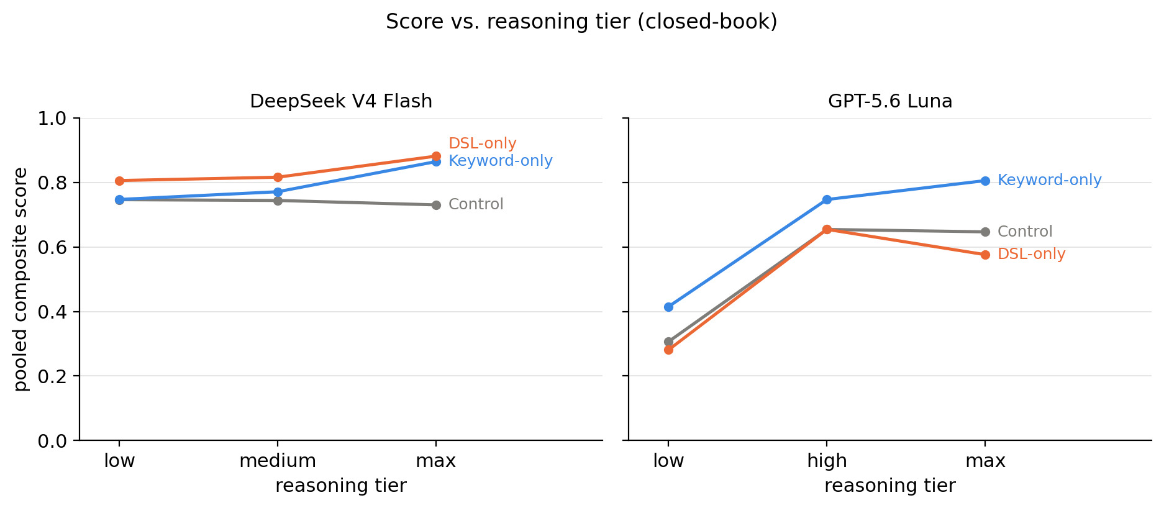
Fig. 8—Closed-book pooled composite score versus reasoning tier (low, high, max; provider settings of the same name) for DeepSeek V4 Flash and GPT-5.6 Luna. Lines compare Control, Keyword-only, and DSL-only; plotted means use n=6–20 trials per model–tier–condition combination. Run on an earlier, smaller task subset and not repeated on the final public slice; reported for the tier trend only.
Process. The traces of the repair cases revealed two complementary debugging strategies and one judge bias. The DSL-only agent begins by importing the entire defective deck into PetroScript, which by design reports every keyword that fails to import in a single pass; validation then reports every physically implausible argument, likewise at once. The effect is lookahead: the agent surfaces essentially every structural defect in one shot, and in the evaluated repair traces this front-loaded diagnosis reached the same terminal state as serial debugging in fewer simulator invocations. The keyword-only agent, by contrast, sees only the first error the simulator emits and repairs defects serially, recompiling at each turn — slower, but with each fix individually verified against a run. The judge bias emerged when these strategies were scored: the initial process judge systematically preferred serial, step-by-step debugging, awarding lower process scores to single-pass solutions that reached identical terminal states, and in several cases flagged honesty violations whose cause was mechanical rather than deceptive. Re-grading the full series under a calibrated rubric — one that scores whether each identified defect carries its own evidence, rather than whether defects were identified one at a time — raised every configuration's process score and raised the full system's most (+0.02 pooled). We report the calibrated scores and note the sensitivity: process judges inherit a procedural aesthetic unless the rubric names the acceptable strategies explicitly. This is the metric-sensitivity finding anticipated in Section 5.4.
Numerical. The DSL path's numerical advantage traced to two mechanisms, unequal in weight. The dominant mechanism was argument discovery. A keywordist is dispatched fire-and-forget against one specification and one manual entry, without the wider problem context; the DSL, by contrast, exposes every argument of a construct as a named, described parameter at the point of authoring, so the agent confronts the full option set on every call and tended to select the appropriate arguments. The keyword path's numerical losses concentrated in a related failure: values relayed into a keywordist brief arrive stripped of context, and in one repair trace the dispatching agent copied a corrupted starter value into the brief as if it were ground truth — the keywordist faithfully preserved the defect it had been implicitly told was correct. The secondary mechanism was the physics guards. Across the evaluated traces the hard-error guards never fired; the advisory warning guards, which flag values that are legal but physically improbable, fired in a minority of cases and prompted the agent to reconsider, and the revised values tended to align more closely with the reference deck.
Structural. In the k=4 series the structural category came out near parity (DSL-only 0.92, keyword-only 0.89), and the earlier keyword-side advantage we had observed in preliminary runs did not persist as the DSL library matured over the evaluation period. What the traces do support is a difference in failure mode rather than level. The keyword path's structural discipline is externalized: syntax is decoupled from engineering judgment, and the generalist dispatches downward — generalist to architect to keywordist — for handcrafted keyword blocks verified against the manual entry, an organization that also proved the most robust across base models (below). The DSL path's structural failures, when they occurred, were tool-boundary failures: the agent authored a correct model but under-attended the final compile-and-deliver step, an error class the harness now checks explicitly. The translation-tax observation stands: the base model proved surprisingly fluent in Eclipse-dialect syntax given the dialect's small footprint on the open web — in the control configuration the agent produced near-parseable decks from the manual alone (structural 0.92 pooled) — so authoring through the DSL imposes a conversion step where direct authoring draws on innate fluency. The control's aggregate weakness is numerical (0.63 pooled), not structural: it writes decks that parse and run but compute the wrong reservoir.
Cross-model comparison. On the full public slice, the DSL-only agent led on DeepSeek V4 Flash (pooled 0.744, against 0.718 keyword-only and 0.694 control), with the margin concentrated in authoring (0.696 against 0.595 and 0.587) and the three configurations within confidence interval of one another on repair. The ordering held on the hard subset (Fig. 7), where iteration against a workspace target is unavailable and the harness showed its strength. Re-running the same series with GPT-5.6 Luna in place of DeepSeek changed the picture: the keyword-only agent led narrowly (pooled 0.521, against 0.507 control and 0.488 DSL-only), and the DSL path split by class — it lifted Luna's authoring (0.438 against 0.266 control) but lowered its editing and repair below the control (0.501 and 0.550 against 0.676 and 0.644) (Table 2). The traces locate the reversal in tool-use style rather than capability. DeepSeek resolves a DSL API question with a bounded number of lookup calls and commits — 0 to 72 ps_explain invocations per trial, with its best trials in the middle of that range. Luna re-queries the same surfaces continuously — 153 to 873 invocations per trial, with its worst scores at the highest counts — and spends its budget re-deriving answers it has already obtained. The keyword path is insensitive to this difference because its unit of work is one keyword against one manual entry, with no accumulated API surface to hold; it was the most stable configuration across both base models and, in a supplementary ablation over reasoning-effort settings, across reasoning tiers as well: reducing Luna's reasoning budget collapsed every configuration (pooled scores of 0.30–0.43 at the lowest tier), while DeepSeek's scores were nearly flat across tiers (Fig. 8). Harness value is therefore not model-independent: the DSL multiplies a model that reads and commits, while the dispatch organization insures against a model that second-guesses.
Table 2—Closed-book composite score on the full public slice at the medium tier by model, task class, and harness path (two trials per task; n is trials). Bootstrap 95% confidence intervals for every cell are the whiskers of Fig. 6; the hard-subset values are shown in Fig. 7.
Model | Task class | Control | Keyword-only | DSL-only
DeepSeek V4 Flash | Authoring | 0.587 (n=64) | 0.595 (n=64) | 0.696 (n=64)
DeepSeek V4 Flash | Editing | 0.828 (n=48) | 0.875 (n=48) | 0.838 (n=48)
DeepSeek V4 Flash | Repair | 0.664 (n=48) | 0.681 (n=48) | 0.674 (n=48)
DeepSeek V4 Flash | Pooled | 0.694 (n=160) | 0.718 (n=160) | 0.744 (n=160)
GPT-5.6 Luna | Authoring | 0.266 (n=64) | 0.361 (n=64) | 0.438 (n=64)
GPT-5.6 Luna | Editing | 0.676 (n=48) | 0.627 (n=48) | 0.501 (n=48)
GPT-5.6 Luna | Repair | 0.644 (n=48) | 0.623 (n=48) | 0.550 (n=48)
GPT-5.6 Luna | Pooled | 0.507 (n=160) | 0.521 (n=160) | 0.488 (n=160)
7. Discussion
The worked cases of Section 6 span the three organizational tiers identified in Section 2: generation of reference problems from stated intent, a black-oil-to-compositional conversion executed mid-conversation for a CO2 scoping study, and a verified custody transfer of a legacy model. Together they establish the two facts on which this section depends. First, engineering intent stated in professional language is sufficient input for an executable model that passes the acceptance criteria of Section 5. Second, the cost of intervening in an existing model scales with the size of the intervention rather than carrying the fixed price of a specialist engagement. Neither was available under the prior regime.
Update economics. Section 2 located the terminal mechanism of model decay in update-cost structure: two prices for any update, and the recurring rational choice to run the model unchanged and qualify the results. Each deferral widens the gap and raises the cost of the eventual reconciliation, so the choice repeats with strengthening justification until the model is uneconomic to modify. Where demonstrated intervention costs scale with intervention size, the rational choice at each update event inverts: incorporating new information becomes cheaper than qualifying a stale result. Model decay, diagnosed in Section 2 as an economic outcome rather than a technical one, reverses by the same mechanism that produced it. A model that is economical to update is updated; a model that is current is consulted; a model that is consulted generates the next update occasion. The loop that formerly drove the inventory toward retirement drives it toward currency, and a current model becomes an ordinary condition of the inventory rather than the exception achieved during major projects.
Collection of prior gains. The five constraints removed over five decades — speed, data logistics, automation, integration, and price — produced null adoption results because each operated on the intensive margin — more use by the existing population — while the extensive margin — new users, occasions, and questions — remained closed. With the translation constraint removed, those investments become operative for the population they were built for: ensemble methods, continuous data streams, and automated optimization acquire the current, trusted models they presuppose. Interrogations priced out under the prior regime — the routine surveillance question, the off-cycle sensitivity, the operational what-if — become economic at the moment they arise.
Harness–model interaction. The two base models responded differently to the same harness surfaces: DeepSeek, the primary development target, consulted the PetroScript interface and committed, while Luna re-queried it, at times hundreds of times per trial, with lower scores at the highest counts. Part of that reflects development effort and part the models' tool-use dispositions; either way, a harness component's benefit is realized per model, and porting an architecture to a new base model is a tuning task rather than a drop-in substitution.
Verification. The architecture is presented in Section 5 at the level required to interpret the results, with the agent-level implementation withheld; the RIGOR benchmark of Section 5.4 is disclosed in full and released as open source with this paper, and it scores any system, including this one, on published criteria independent of implementation. The distinction from the prior waves cataloged in Section 2 is structural: their claims could only be repeated; these are released so that they can be failed in public.
Cost. The cost of intervention is small in absolute terms. Across the closed-book ablation at the medium tier, a trial cost $0.18 to $0.28 on DeepSeek V4 Flash and $1.32 to $3.85 on GPT-5.6 Luna, the DSL path being the most expensive on both; wall-clock per trial ran roughly 26 to 30 minutes on DeepSeek and 12 to 21 on Luna, the DSL path again the longest on Luna (Fig. 9). A trial is a complete authoring, editing, or repair job against a running simulator, so these figures bound the cost of the three organizational tiers: a routine update, a full model conversion, and a custody transfer each fall within a few trials of tokens, against the hours to days of specialist time the same work consumes today.
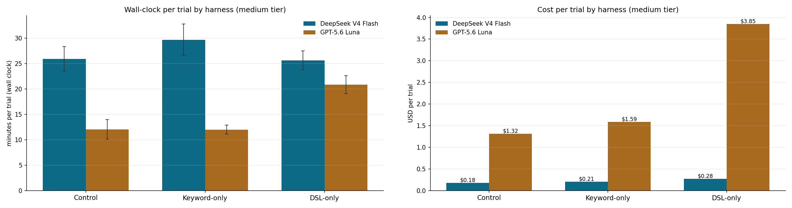
Fig. 9—Wall-clock (left) and cost (right) per trial by harness configuration at the medium tier; whiskers are bootstrap 95% confidence intervals.
Limitations. The present scope admits definite limits. CLARISSA consumes geological descriptions; it does not construct them, and the quality of a generated model remains bounded by the quality of the description supplied. The demonstrations run on a single simulator; simulator agnosticism is argued from the architecture, not yet demonstrated by retargeting; PetroScript itself currently compiles only to the Eclipse dialect, so simulators with their own input languages, CMG among them, are outside its present reach. The worked cases are of reference-problem and single-asset scale; fleet-scale operation is unreported. The elicitation protocols for under-determined specifications are specified as a class rather than exhaustively. RIGOR is presented, not yet community-exercised; its value as an instrument depends on submissions beyond our own. Finally, the acceptance criteria are necessary, not sufficient: a model passing every registered check is well-formed and self-consistent, not thereby fit for a specific decision, and fitness assessment remains with the engineer, who is the final gate in the acceptance chain.
Three further limitations attach to the benchmark results. Model coverage was confined by budget to two bases — GPT 5.6 Luna and DeepSeek V4 — chosen for in-context-learning headroom and capability per dollar; V4 Flash also runs locally on modest hardware, giving the ring-fencing and version stability field deployment requires. Broader coverage is one purpose of the open release; whether the demonstrated lift carries to frontier-class models such as 5.6 Sol or Fable, and whether it grows or shrinks as base capability improves, remains untested. The DSL and prompts were tuned within the available development time rather than to convergence, and both are expected to improve. Finally, the benchmark is small relative to AI/ML community norms, its 135 tasks drawn from the roughly 700 available open OPM decks, and no results from systems other than CLARISSA are yet available on it; subsequent versions of RIGOR will be larger.
Future work. The public slice of RIGOR will be open-sourced on release of this paper, with the private slice remaining available only through the hosted API described in Section 5.4; community contributions of cases are invited. RIGOR V2 is in development, with substantially harder and less structured tasks. The agent's scope will widen in parallel: the present system is confined to reservoir engineering and expects a completed geomodel among its inputs, and initial testing has begun on an end-to-end system spanning petrophysical analysis, geomodel analysis, and reservoir engineering. That scope unlocks the large public corpora of well-log data (NLOG, SODIR, NDIC, and others) and, with it, the enabler identified in Section 5.3: a system whose operation generates the sampled reasoning traces and reference decks required to bootstrap a self-supervised regime under which fine-tuning becomes viable. PetroScript will be extended to non-Eclipse targets, beginning with CMG. Two releases are planned to seed adoption: a complete mirror of the opm-tests corpus authored in PetroScript, and the library itself alongside RIGOR. The mirror serves the argument of Section 5.3 directly — a public corpus in a high-resource language is how deck authoring enters the training distribution of general code models — and contributions from institutions, vendors, and model providers are invited on that basis.
8. Conclusions
1. Five constraints on simulation adoption — speed, data logistics, automation, integration, and price — have been removed at industrial scale over five decades, each with a null adoption result. The binding constraint is identified by elimination as the manual translation of engineering intent into simulator input, an artifact legible chiefly to specialists (Section 2).
2. The translation constraint is addressable by a conversational agent system that preserves intent as the durable artifact and treats the simulator deck as a regenerated compilation product. The enabling technology category — language-model agents able to act across a semantic boundary — did not previously exist (Sections 3, 5).
3. Correctness is not entrusted to the conversational interface. Every generated model is gated by the target simulator's own parser, reconciled by conservation identities, screened against classical solutions, and delivered with audit artifacts; where two translation authorities cover the same ground, release requires their agreement, and the criteria are published as a versioned check registry (Section 5.1).
4. Worked demonstrations spanning the three organizational tiers — reference-problem generation from stated intent, a mid-conversation black-oil-to-compositional CO2 scoping study, and verified custody transfer of a legacy model — establish that intervention cost scales with intervention size, inverting the update economics that drive model decay (Sections 6, 7).
5. The claims above are submitted to an open benchmark, RIGOR, scored on published criteria independent of implementation, under which they can be tested and failed by any party (Section 5.4).
6. The promise of reservoir simulation was not overstated; it was undersupplied by one component. This paper has presented that component and the instrument by which its supply can be verified.
Acknowledgments
The authors used Claude Fable 5 (Anthropic) to assist in editing the manuscript text, including the restructuring of several sections in response to review. All technical content, system designs, benchmark construction, data, results, and conclusions are the authors' own. The authors reviewed all AI-assisted text and retain full responsibility for the manuscript.
References
Arps, J. J. 1945. Analysis of Decline Curves. In Transactions of the AIME, Vol. 160, 228–247. New York, New York, USA: American Institute of Mining and Metallurgical Engineers. https://doi.org/10.2118/945228-G.
Aziz, K. and Settari, A. 1979. Petroleum Reservoir Simulation. London, UK: Applied Science Publishers.
Chen, M., Tworek, J., Jun, H. et al. 2021. Evaluating Large Language Models Trained on Code. arXiv:2107.03374. https://arxiv.org/abs/2107.03374.
Coats, K. H. 1980. An Equation of State Compositional Model. SPE J. 20 (5): 363–376. https://doi.org/10.2118/8284-PA.
Datta-Gupta, A. and King, M. J. 2007. Streamline Simulation: Theory and Practice. SPE Textbook Series, Vol. 11. Richardson, Texas, USA: Society of Petroleum Engineers. https://doi.org/10.2118/9781555631116.
Jansen, J. D., Douma, S. G., Brouwer, D. R. et al. 2009. Closed-Loop Reservoir Management. Presented at the SPE Reservoir Simulation Symposium, The Woodlands, Texas, USA, 2–4 February. https://doi.org/10.2118/119098-MS.
Jevons, W. S. 1865. The Coal Question: An Inquiry Concerning the Progress of the Nation, and the Probable Exhaustion of Our Coal-Mines. London, UK: Macmillan and Co.
Jimenez, C. E., Yang, J., Wettig, A. et al. 2024. SWE-bench: Can Language Models Resolve Real-World GitHub Issues? Presented at the Twelfth International Conference on Learning Representations, Vienna, Austria, 7–11 May. https://arxiv.org/abs/2310.06770.
Lozhkov, A., Li, R., Ben Allal, L. et al. 2024. StarCoder 2 and The Stack v2: The Next Generation. arXiv:2402.19173. https://doi.org/10.48550/arXiv.2402.19173.
Mallet, J.-L. 2002. Geomodeling. Applied Geostatistics Series. Oxford, UK: Oxford University Press.
Merrill, M. A., Shaw, A. G., Carlini, N. et al. 2026. Terminal-Bench: Benchmarking Agents on Hard, Realistic Tasks in Command Line Interfaces. Presented at the Fourteenth International Conference on Learning Representations, Rio de Janeiro, Brazil, 23–27 April. https://proceedings.iclr.cc/paper_files/paper/2026/hash/444a3737adaee10d86ad2ef5f74468e6-Abstract-Conference.html.
Open Porous Media (OPM). 2025a. OPM Flow Reference Manual 2025.10, rev. 0. https://github.com/OPM/opm-reference-manual/releases/download/release%2F2025-10%2Frev-0/OPM_Flow_Reference_Manual_2025-10_Rev-0_compressed.pdf.
Open Porous Media (OPM). 2025b. opm-tests repository, commit 795d6fa462ee8d75f25539127358aa4a779c55fc. Accessed 10 August 2026. https://github.com/OPM/opm-tests/tree/795d6fa462ee8d75f25539127358aa4a779c55fc.
Open Porous Media (OPM). 2026. OPM Public Repositories. GitHub organization, accessed 10 August 2026. https://github.com/OPM.
Peaceman, D. W. 1977. Fundamentals of Numerical Reservoir Simulation. Developments in Petroleum Science, Vol. 6. Amsterdam, The Netherlands: Elsevier Scientific Publishing Company.
Perrin, M. and Rainaud, J.-F. 2013. Shared Earth Modeling: Knowledge Driven Solutions for Building and Managing Subsurface 3D Geological Models. Paris, France: Editions Technip.
Rasmussen, A. F., Sandve, T. H., Bao, K. et al. 2021. The Open Porous Media Flow Reservoir Simulator. Computers & Mathematics with Applications 81: 159–185. https://doi.org/10.1016/j.camwa.2020.05.014.
Thiele, M. R. 2001. Streamline Simulation. Presented at the 6th International Forum on Reservoir Simulation, Schloss Fuschl, Austria, 3–7 September. https://streamsim.com/papers/rsf2001.pdf (accessed 10 August 2026).
Wiegand, K., Bedewi, M., Mukundakrishnan, K. et al. 2024. Using Generative AI to Build a Reservoir Simulation Assistant. Presented at ADIPEC, Abu Dhabi, UAE, 4–7 November. https://doi.org/10.2118/221987-MS.
Zhao, X., Wei, S., Wang, L. et al. 2025. Large Language Model Empowered Automated Reservoir Agent: A Win-Win Strategy for Reservoir Intelligent Management and Transformation. Presented at ADIPEC, Abu Dhabi, United Arab Emirates, 3–6 November. https://doi.org/10.2118/229646-MS.
Zheng, L., Chiang, W.-L., Sheng, Y. et al. 2023. Judging LLM-as-a-Judge with MT-Bench and Chatbot Arena. In Advances in Neural Information Processing Systems 36, 46595–46623. Presented at the 37th Conference on Neural Information Processing Systems, New Orleans, Louisiana, USA, 10–16 December. https://doi.org/10.48550/arXiv.2306.05685.

